**41.ALV_GRID_LOGO Output**

Go to OAER. Give the following details and execute.

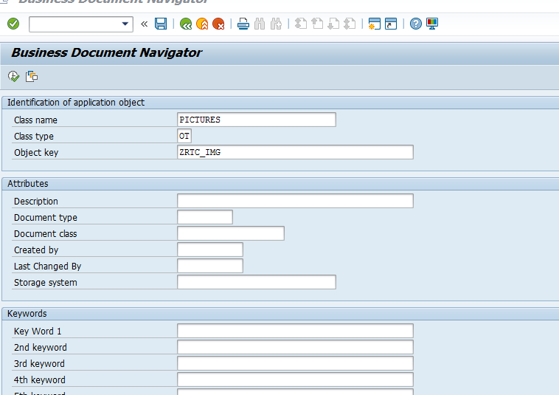

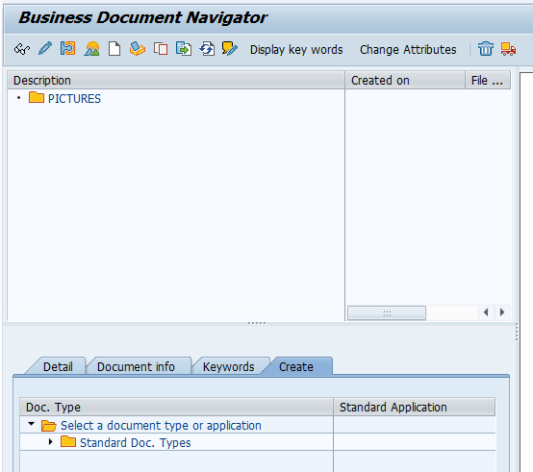

Expand the Create tab. Double click on Attachment.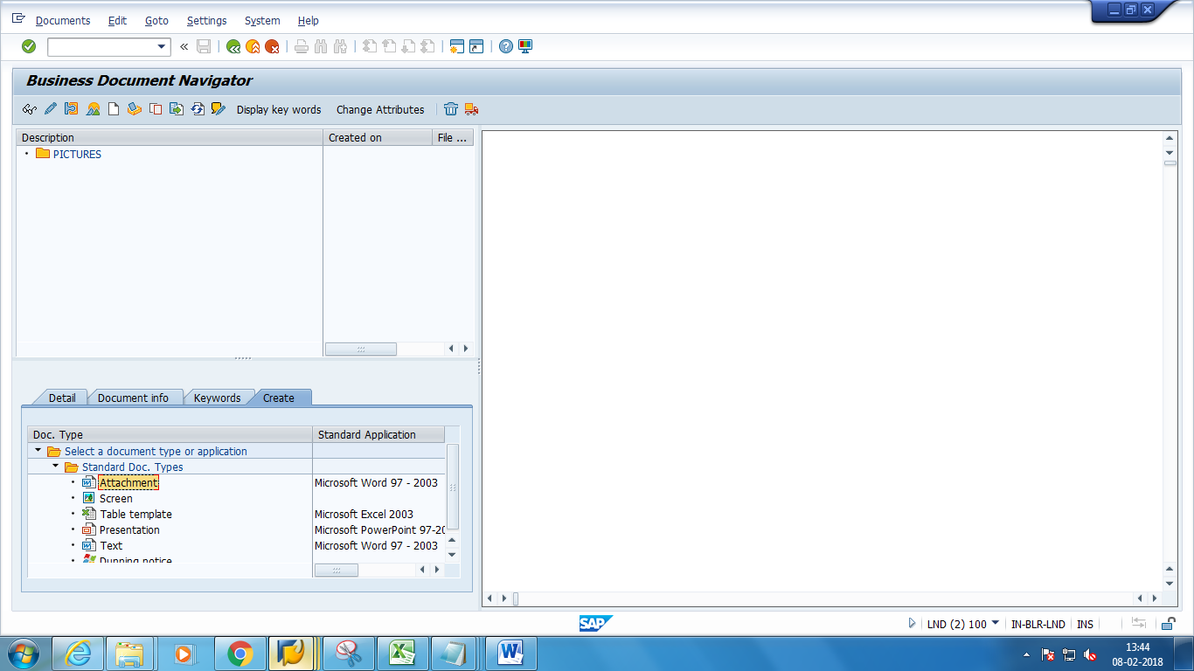

Choose your image.

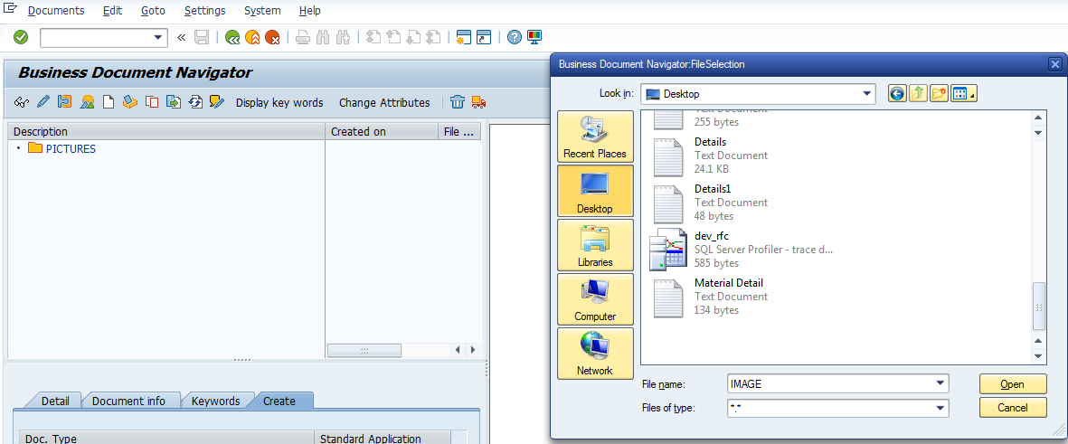

You will get a successful message ‘Document saved ‘

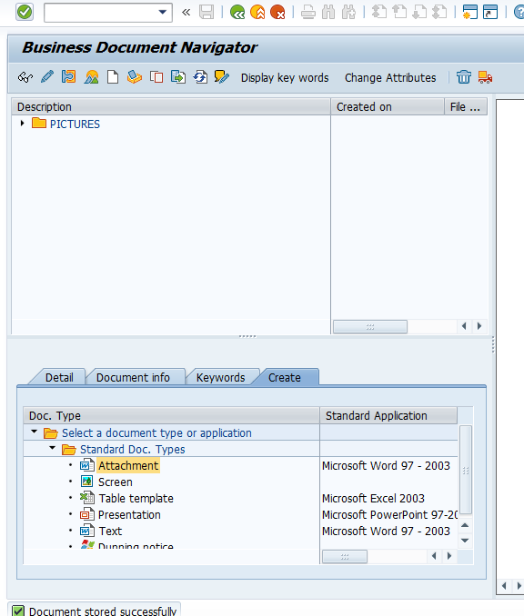

Run the report in se38.Below is the Selection screen .Give a suitable CARRID and Execute.

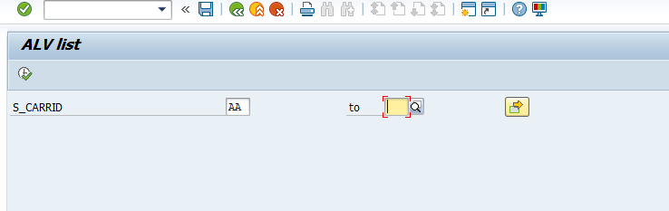

The expected output is as follows

